1.
#pragma warning (disable:4996)
#include <stdio.h>
struct date {
int year;
int month;
int day;
};
int main()
{
struct date d;
scanf("%d%d%d", &d.year, &d.month, &d.day);
printf("%d-%d-%d", d.year, d.month, d.day);
return 0;
}
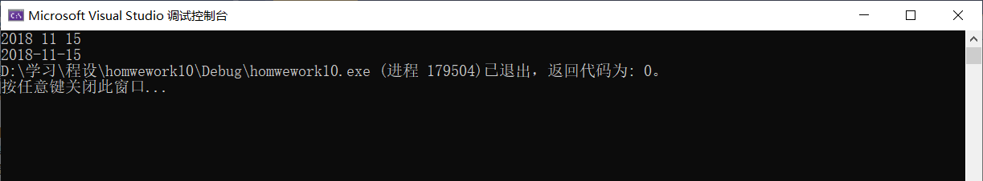

2.
#pragma warning (disable:4996)
#include <stdio.h>
typedef struct {
int ID;
char name[20];
int score[5];
int sum;
} STUDENT;
typedef STUDENT* LPSTUDENT;
void Sort(LPSTUDENT pst[], int n);
void Sum(LPSTUDENT pst[], int n);
LPSTUDENT Find(LPSTUDENT pst[], int n, int val);
int main()
{
STUDENT st[20];
LPSTUDENT pst[20], p;
int n, a;
printf("Please input the number of the students.\n");
scanf("%d", &n);
printf("Input their information: ID, name and scores.\n");
for (int i = 0; i < n; ++i) {
scanf("%d%s", &st[i].ID, st[i].name);
for (int j = 0; j < 5; ++j)
scanf("%d", &st[i].score[j]);
pst[i] = &st[i];
}
Sum(pst, n);
Sort(pst, n);
printf("Please input the ID of the student you want to find. And input -1 to end.\n");
scanf("%d", &a);
while (a != -1) {
p = Find(pst, n, a);
if (p) {
printf("ID: %d Name: %s scores: ", p->ID, p->name);
for (int i = 0; i < 5; ++i)
printf("%d ", p->score[i]);
printf("Total score: %d\n", p->sum);
}
else printf("Cannot Find!\n");
printf("Please input another ID of the student you want to find. And input -1 to end.\n");
scanf("%d", &a);
}
printf("==========================\n排序结果：\n");
for (int i = 0; i < n; ++i) {
printf("ID: %d Name: %s scores: ", pst[i]->ID, pst[i]->name);
for (int j = 0; j < n; ++j)
printf("%d ", pst[i]->score[j]);
printf("Total score: %d", pst[i]->sum);
}
return 0;
}
void Sort(LPSTUDENT pst[], int n)
{
int k = 0, m = n - 1, k0, m0;
while (k < m) {
m0 = m;
m = k;
for (int i = k; i < m0; ++i) {
if (pst[i]->sum < pst[i + 1]->sum) {
LPSTUDENT tmp = pst[i];
pst[i] = pst[i + 1];
pst[i + 1] = tmp;
m = i;
}
}
k0 = k;
k = m;
for (int j = m; j > k0; --j) {
if (pst[j]->sum > pst[j - 1]->sum) {
LPSTUDENT tmp = pst[j];
pst[j] = pst[j - 1];
pst[j - 1] = tmp;
}
}
}
}
void Sum(LPSTUDENT pst[], int n)
{
for (int i = 0; i < n; ++i)
{
pst[i]->sum = 0;
for (int j = 0; j < 5; ++j)
pst[i]->sum += pst[i]->score[j];
}
}
LPSTUDENT Find(LPSTUDENT pst[], int n, int val)
{
for (int i = 0; i < n; ++i)
if (pst[i]->ID == val)
return pst[i];
return NULL;
}
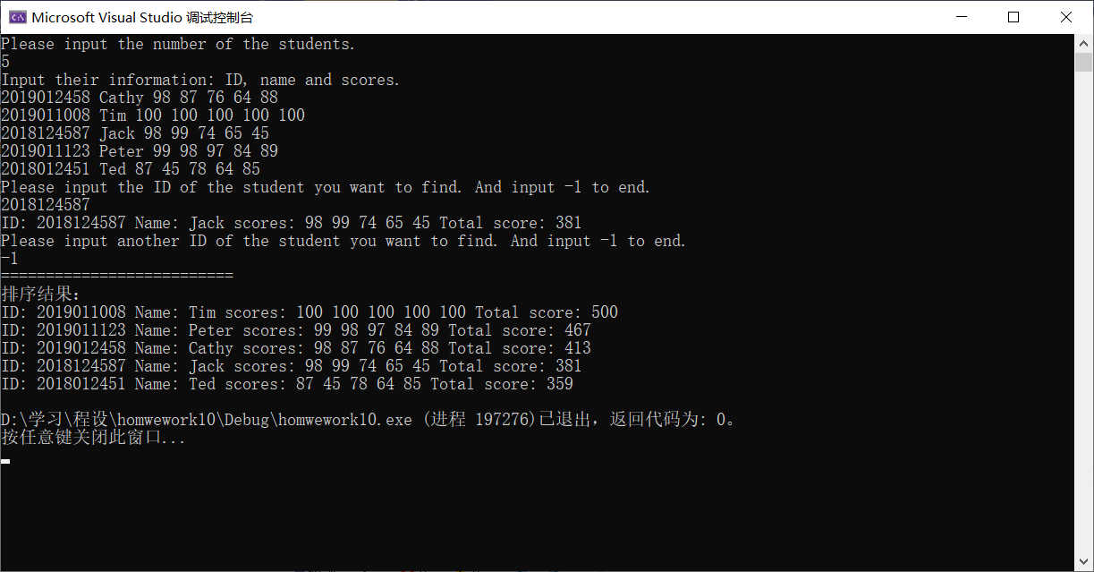
11.
#define _CRT_SECURE_NO_WARNINGS
#include <stdio.h>
#include <stdlib.h>
#include <string.h>

typedef struct student
{
int num;
char name[10];
int grade;
} Student;

typedef struct stunode
{
int num;
char name[10];
int grade;
struct stunode *next;
} StuNode, *PStuNode;

#define STU_NUM 13

int mainc(void)
{
Student stu[STU_NUM];
PStuNode head = NULL, p;
int i;
for (i = 0; i < STU_NUM; ++i)
{
scanf("%d%s%d", &stu[i].num, stu[i].name, &stu[i].grade);
}

//Build the list

for (i = STU_NUM - 1; i >= 0; --i)
{
p = (PStuNode)malloc(sizeof(StuNode));

if (p == NULL)
{
perror("Memory allocation failed!\n");
exit(1);
}

p->num = stu[i].num;
p->grade = stu[i].grade;
strcpy(p->name, stu[i].name);

//As the question requests, insert the new node to the **head** of the list, **not the tail**!!!!!!

if (head == NULL)
{
head = p;
p->next = NULL;
}
else
{
p->next = head;
head = p;
}
}

//Output the students and delete the list

printf("\n========================\n\n");
printf("num name grade\n\n");
while (head)
{
p = head->next;
printf(" %02d%10s%10d\n", head->num, head->name, head->grade);
free(head);
head = p;
}

return 0;
}

#undef STU_NUM
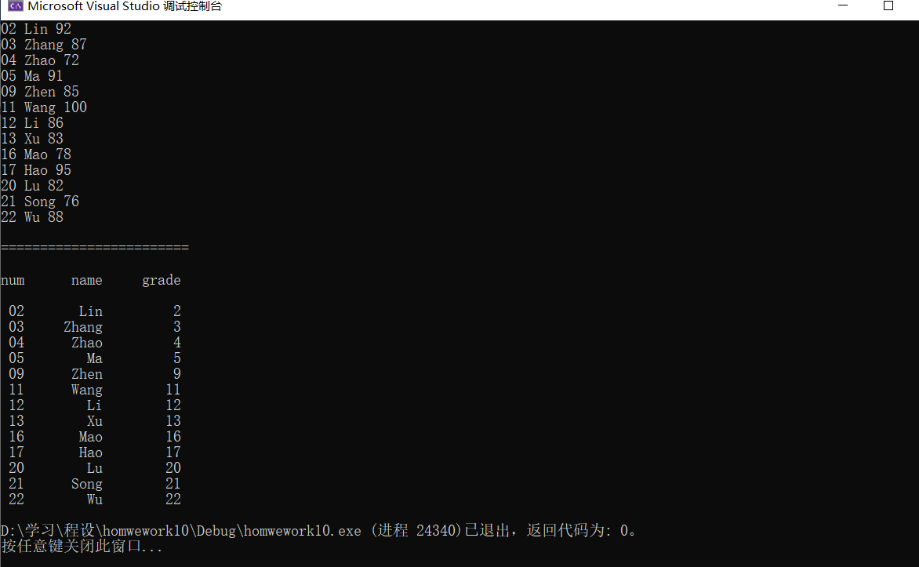

12.
#pragma warning (disable:4996)
#include <stdio.h>
#include <stdlib.h>
#include <string.h>
typedef struct student {
int num;
char name[10];
int grade;
} STU;
typedef STU* LPSTU;
typedef struct stunode {
LPSTU data;
struct stunode* next;
} STUNODE;
typedef STUNODE* LPSTUNODE;
void output_delete(LPSTUNODE head);
int main() {
int k;
STU st[13];
LPSTUNODE p = NULL, head[3] = { NULL, NULL, NULL }, q[3] = { NULL, NULL, NULL };
for (int i = 0; i < 13; ++i) {
scanf("%d%s%d", &st[i].num, st[i].name, &st[i].grade);
}

//Insert

for (int i = 0; i < 13; ++i) {
k = 10 - st[i].grade / 10;
if (k == 0) ++k;
p = (LPSTUNODE)malloc(sizeof(STUNODE));
if (!head[k - 1]) head[k - 1] = p;
else q[k - 1]->next = p;
p->data = &st[i];
p->next = NULL;
q[k - 1] = p;
}

//output and delete

printf("\nFrom 90 To 100:\n");
output_delete(head[0]);
printf("\nFrom 80 To 89:\n");
output_delete(head[1]);
printf("\nFrom 70 To 79:\n");
output_delete(head[2]);
return 0;
}
void output_delete(LPSTUNODE head) {
int tmp;
LPSTUNODE p;
printf("========================\n\n");
printf("num name grade\n\n");
while (head) {
p = head->next;
printf(" %02d", head->data->num);
tmp = 10 - strlen(head->data->name);
for (int i = 0; i < tmp; ++i) {
printf(" ");
}
printf("%s %5d\n", head->data->name, head->data->grade);
free(head);
head = p;
}
}
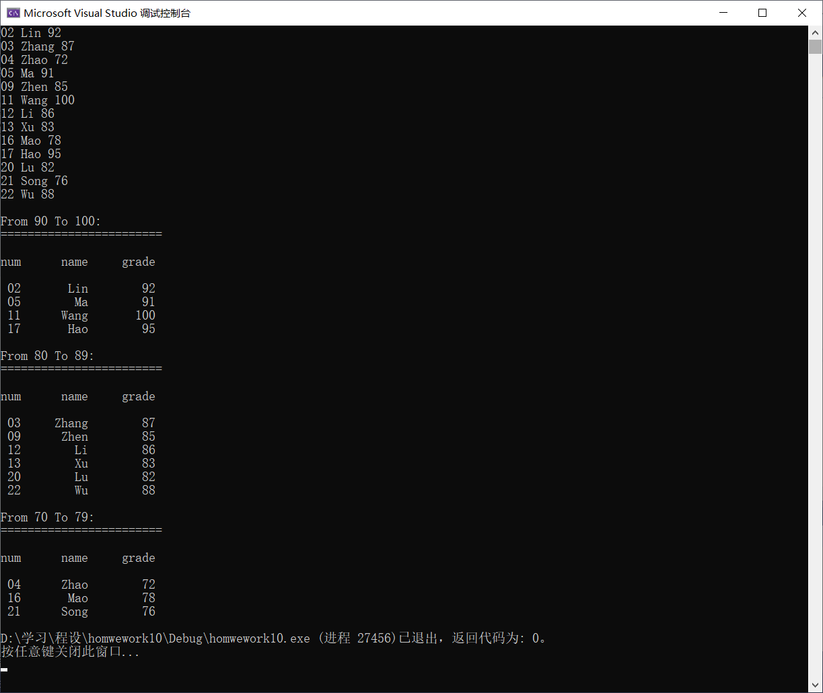

约瑟夫问题：
#pragma warning (disable:4996)
#include <stdio.h>
#include <stdlib.h>
typedef struct node {
int num;
struct node* next;
} NODE;
typedef NODE* LPNODE;
void pop(LPNODE* ptr, LPNODE* old);
int main() {
int m, n ,itr = 1, sum = 0;
LPNODE head = NULL, p = NULL, q = NULL;
scanf("%d%d", &m, &n);
p = (LPNODE)malloc(sizeof(NODE));
head = p;
p->num = 1;
p->next = NULL;
q = p;
for (int i = 2; i <= m ; ++i) {
p = (LPNODE)malloc(sizeof(NODE));
q->next = p;
p->next = NULL;
p->num = i;
q = p;
}
q->next = head;
while (sum != m - 1) {
if (itr == n) {
itr = 0;
pop(&head, &p);
++sum;
}
else {
p = head;
head = head->next;
}
++itr;
}
printf("%d persons, every %d persons out:\nThe left number is %d\n", m, n, head->num);
free(head);
return 0;
}
void pop(LPNODE * ptr, LPNODE * old) {
LPNODE p = *ptr;
if (!*ptr) return;
*ptr = p->next;
free(p);
(*old)->next = *ptr;
}
